

Características de Access points Aruba networks Exteriores y interiores

AP Exteriores

AP80

Antenas Compatibles

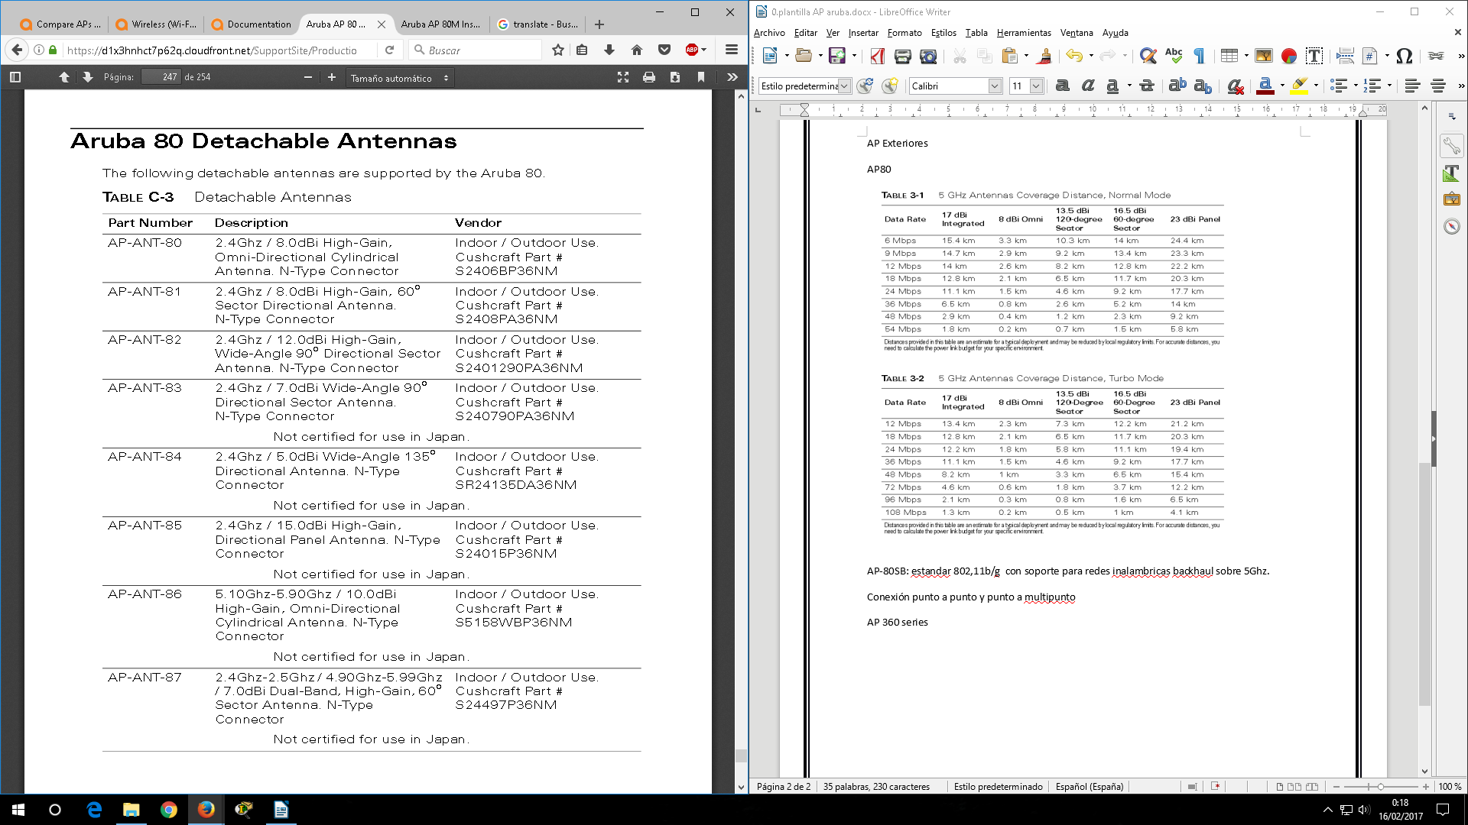

AP-80SB: estándar 802,11b/g con soporte para redes inalámbricas backhaul sobre 5Ghz.

Conexión punto a punto y punto a multipunto. Este AP incluye una antena de 17 dBi a 5,150Ghz-5,85GHZ Tipo de conexión N-type female.

“AP80 series supports only non-standard 802.3af Power over Ethernet “. El inyector debe ser usado.

“AP-80SB and AP-80MB models have one 10BASE-T/100BASE-TX “.

AP-80MB: estándar 802.11a/b/g con soporte para redes inalámbricas backhaul sobre 5Ghz o 2,4Ghz. 2 antenas desmontables de 5 y 2,4 GHz , no contiene antena integrada como el 80SB

Consumo AP-80: 48V DC a 1.2A (30W)

Clientes máximos: 128.

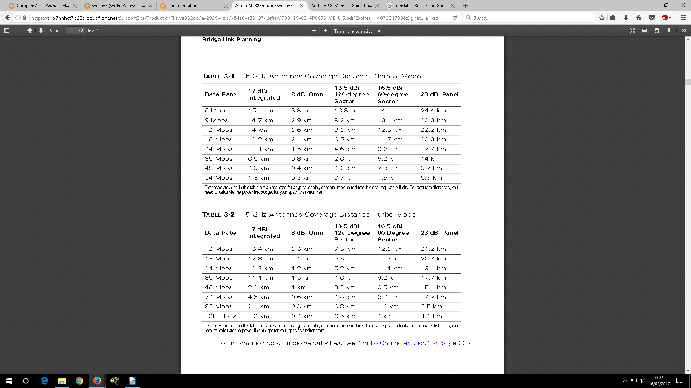

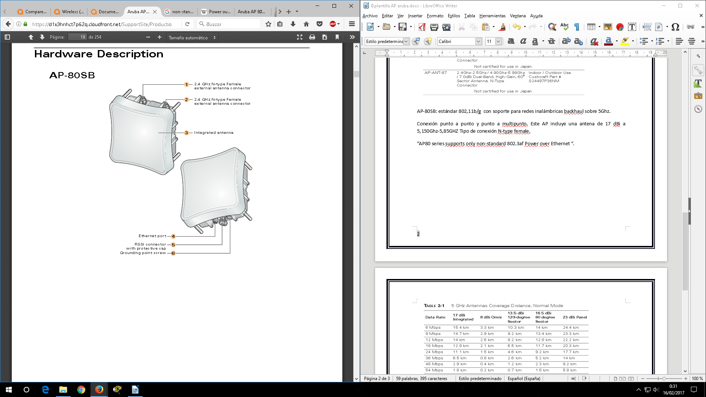

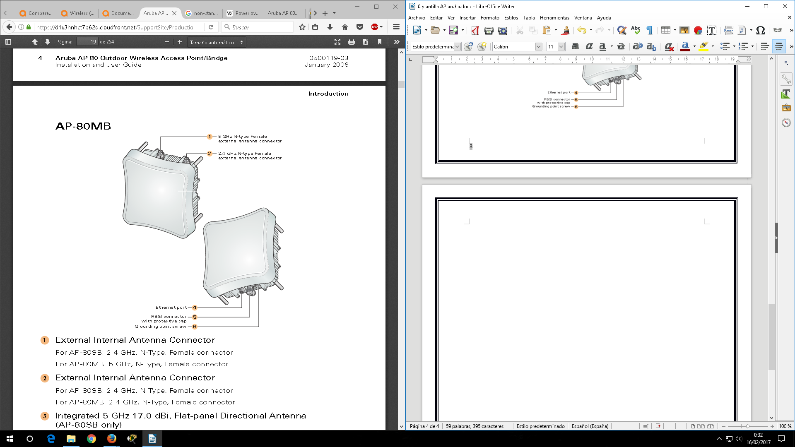

AP 85:

AP-85TX (Ethernet) “PoE compatible”;” PoweR 12 VDC to 2 A por inyector”

“LAN/POE 48 VDC, 350 mA”

“supports SPoE Serial Power over Ethernet”, “1 Puerto 10/100Base-T Fast Ethernet”

AP-85FX (Multi-mode Fiber) “100BASE-FX ” multimodo para distancias cortas

AP-85LX (Single-mode Fiber) “100BASE-LX ” monomodo para distancias largas

FX/LX Ambos aceptan:” PoweR 12 VDC to 2 A por inyector”,

Todos trabajan con el estándar IEEE 802.11 a/b/g

“requires ArubaOS 3.2.0 or later”.

“The AP-85 Series requires the use of detachable outdoor antennas RADIO 0 supports 2.4 Ghz, RADIO 1 supports 5 GHz”.

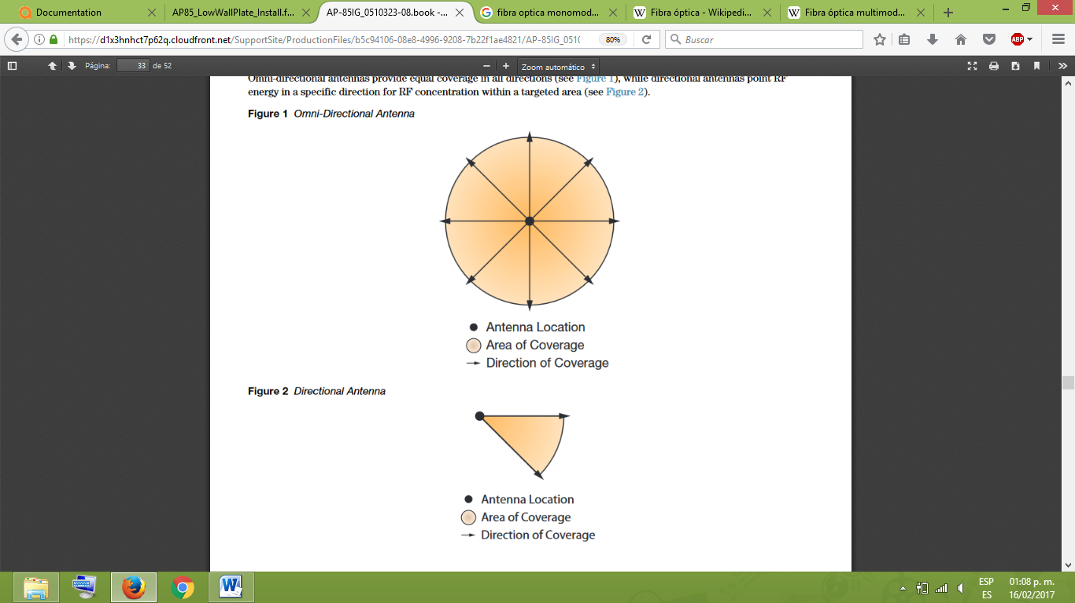

AP175: OS ArubaOS 5.0.2.1 or late

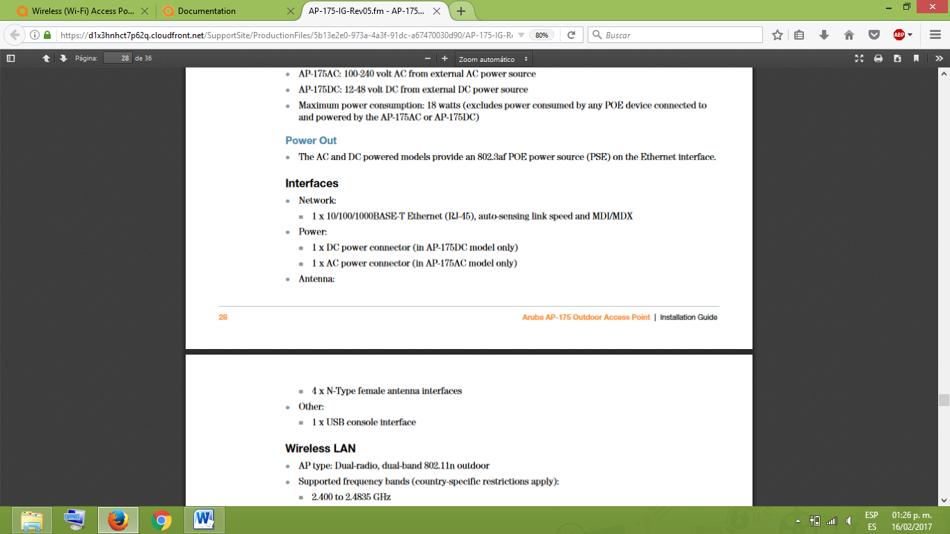



Las diferencias entre estos AP son las características electicas

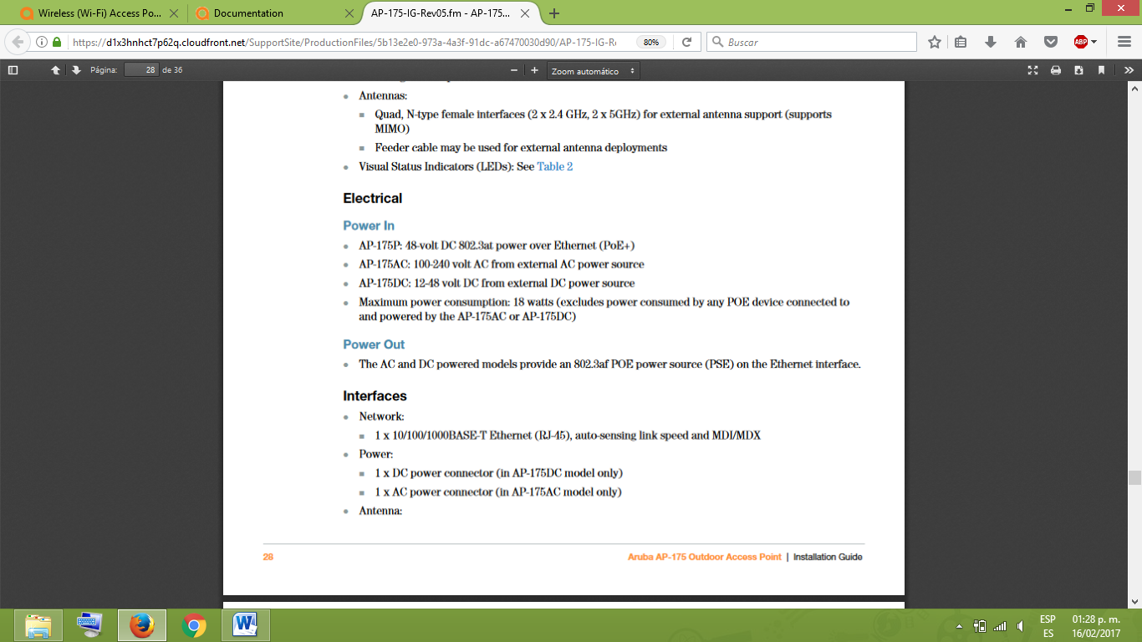

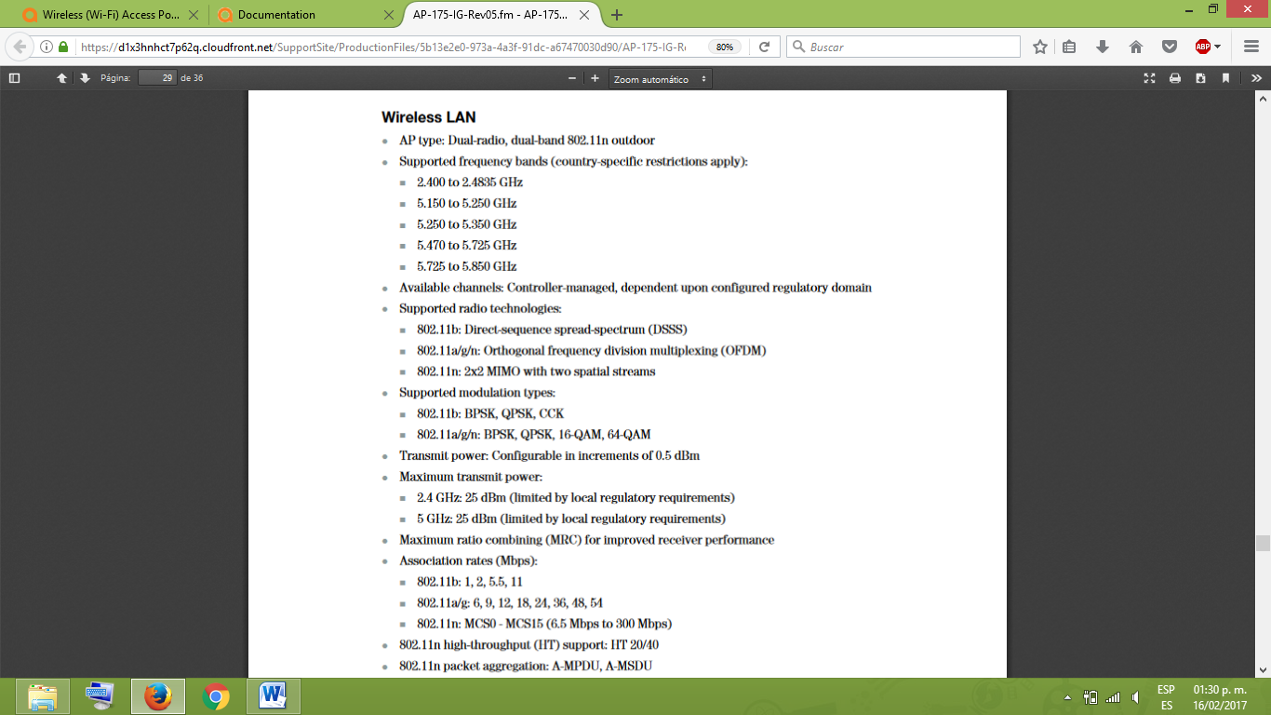

AP Interiores

AP135: requires ArubaOS 6.1 or later.

“The AP-134 is designed for use with external antennas. The AP-135 is equipped with internal antennas.”

6 integrated antenna elements (AP-135)

3 RP-SMA interfaces for external antennas (AP-134)

2 x 10/100/1000 Base-T auto-sensing Ethernet RJ-45 Interfaces

MDI/MDX

IEEE 802.3 (10Base-T), IEEE 802.3u (100Base-T). IEEE 802.3ab (1000Base-T)

Power over Ethernet (IEEE 802.3at compliant), 48V DC/350mA

Power: 12 VDC power interface, supports powering through an AC-to-DC mains electric power adapter.

802.11b - 1, 2, 5.5, 11 Mbps per channel

802.11g - 6, 9, 12, 18, 24, 36, 48 and 54 Mbps per channel

802.11a - 6, 9, 12, 18, 24, 36, 48 and 54 Mbps per channel

802.11n - Data rate MCS0 – MCS23 (from 6.5 Mbps to 450 Mbps)

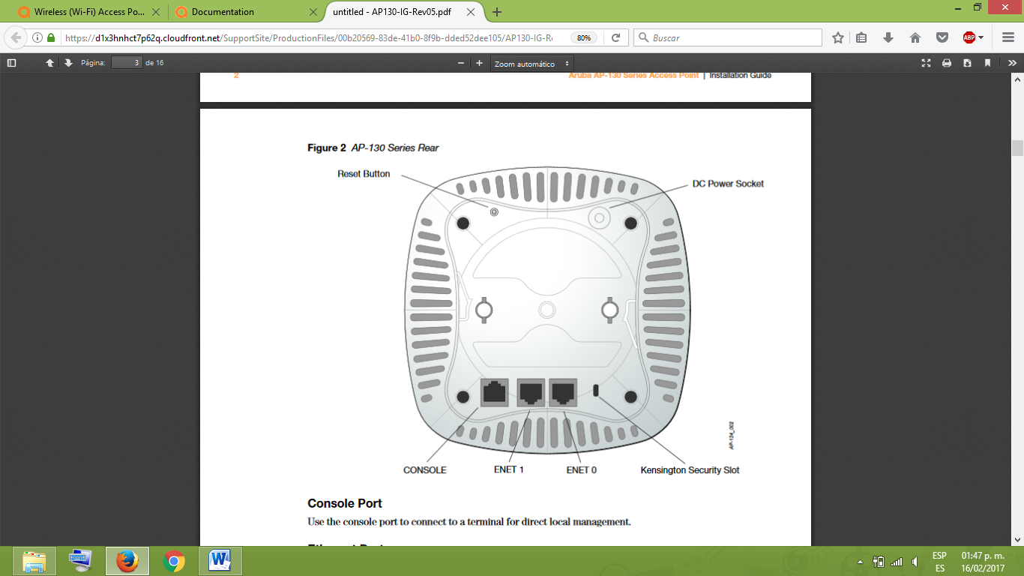

AP60:

“ArubaOS 2.2 releases or lower. Single antenna operation is supported with ArubaOS 2.3 or higher”.

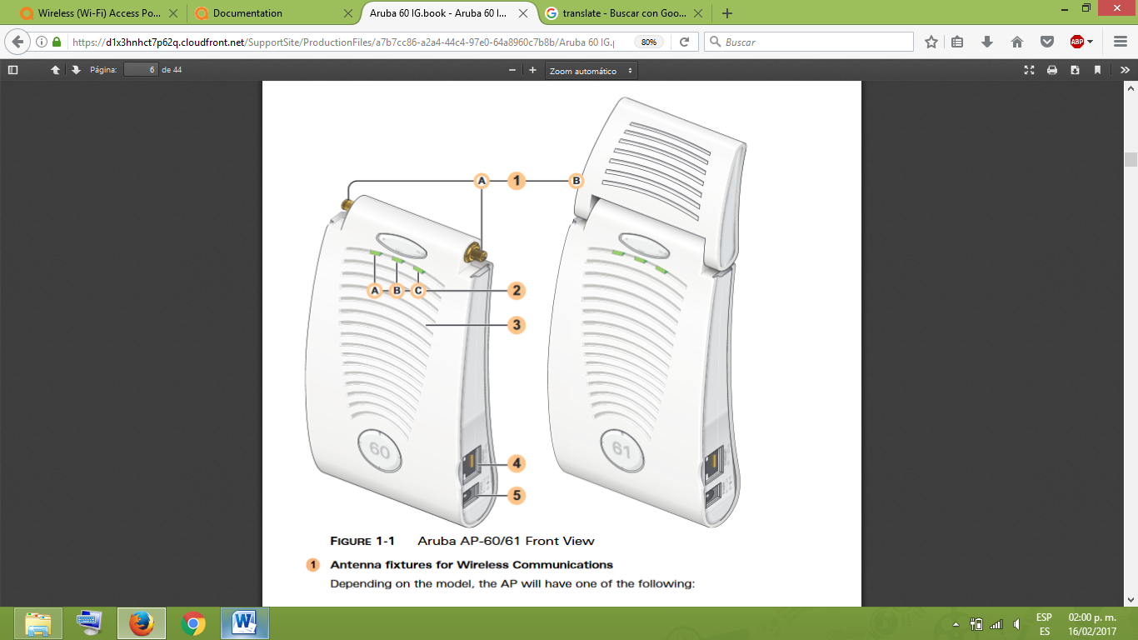

Ap60 con 2 interfaces externas, ap61 con antenas internas.

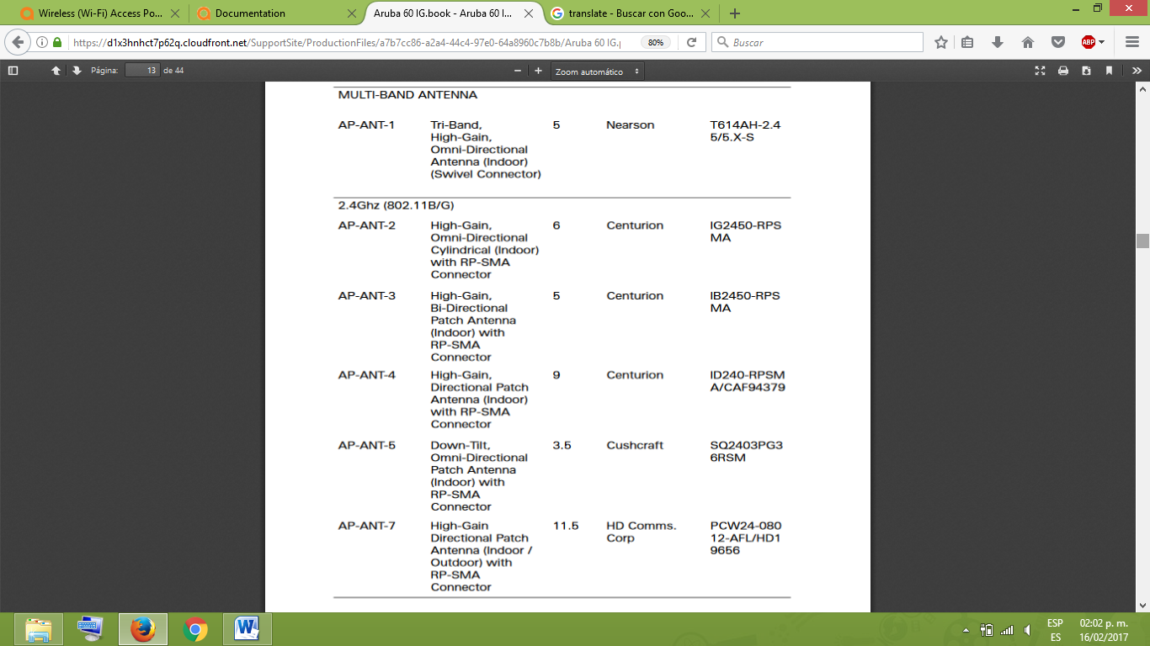

AP60 y AP 61:

Soportan 802.11 a/b/g, soportan 64 clientes máximo

1 x 10/100 Base-TX auto-sensing Ethernet

RJ-45 Interface (Auto-sensing MDI/MDX)

Serial and Power Over

Ethernet - 48 VDC/200 mA Power Over Ethernet (802.3af compliant)

1 x 5V DC Power Interface

Consume 10W

AP70:

Estandar 802.11 a/b/g

802.11 a

6, 9, 12, 18, 24, 36, 48, 54 Mbps per channel

802.11 b

1, 2, 5.5, 11 Mbps per Channel

802.11 g

6, 9, 12, 18, 24, 36, 48, 54 Mbps per channel

Maximos de clients 64.

2 x 10/100 Base-TX RJ-45 auto-sensing Ethernet interfaces:

Port ENET0

> Supports auto-sensing MDI/MDX

> Supports Power Over Ethernet 48V DC / 250mA (802.3af compliant)

> Supports Serial Over Ethernet

Port ENET1

> Does not support auto-sensing

> Supports Power Over Ethernet 48V DC / 250mA (802.3af compliant)

> Does not support Serial Over Ethernet

USB ver 2.0 Interface

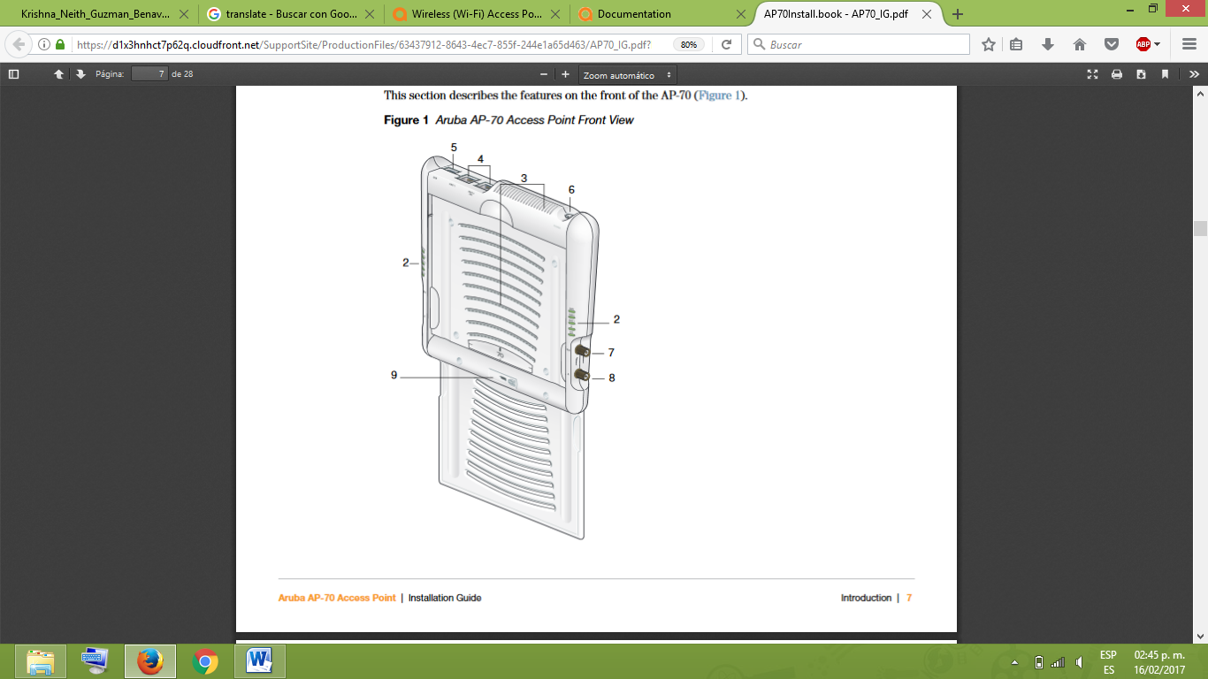

2 interfaces para antenas externas

AP 104, AP105 (antenas internas):

Mismas características

IEEE 802.11a/b/g/n operation as a wireless access point, Central management configuration and upgrades through an Aruba Controller.

1 x 10/100/1000Base-T auto-sensing Ethernet RJ-45 Interfaces

MDI/MDX

Power over Ethernet (IEEE 802.3af compliant), 48V DC/350mA

Power:

12 VDC power interface, supports powering through an AC-to-DC

AP124:

3 x RP-SMA interfaces for detachable antenna

2 x 100/1000 Base-T auto-sensing Ethernet RJ-45 Interfaces

MDI/MDX

Power over Ethernet (IEEE 802.3af compliant), 48V DC/200mA

5 VDC power interface, supports powering through an AC-to-DC

Integrated 802.11a/b/g/n omni-directional high-gain antenna

2.4 – 2.5 GHz/3.2 dBi (max)

5.180 – 5.825 GHz/5.2 dBi (max)

AP205H:

IEEE 802.11a/b/g/n/ac operation as a wireless access point

Compatibility with IEEE 802.3af/at PoE

Supports PoE-in to E0 port (only)/PoE-out from E3 port (only)

4x 10/100/1000 Base-T auto-sensing Ethernet RJ-45 interface (E0-E3)

2x passive RJ-45 Pass-Through interface (E0/PT and PT)

MDI/MDX

48VDC power interface, supports powering through an AC-to-DC

AP215:

The AP-210 Series requires ArubaOS 6.4.2.0 or later.

Ap214 antenas externas, ap215 antenas internas

IEEE 802.11a/b/g/n/ac

5 GHz: Indicates the status of the 802.11a/n radio

2.4 GHz: Indicates the status of the 802.11b/g/n radio

1x 10/100/1000 auto-sensing Ethernet RJ-45 Interface

MDI/MDX

Permite PoE o 12V DC

AP 225:

The AP-220 Series requires ArubaOS 6.3.0.0 or later.

Necesitan controladora Aruba

IEEE 802.11a/b/g/n/ac operation as a wireless access point

AP-220 Series is equipped with two10/100/1000Base-T (RJ-45) auto-sensing, MDI/

MDX

Antenas internas

AP103:

IEEE 802.11a/b/g/n operation as a wireless access point

Compatibility with IEEE 802.3af PoE

5 GHz: Indicates the status of the 802.11a/n radio

2.4 GHz: Indicates the status of the 802.11b/g/n radio

48V DC (nominal)

12v dc power interface

The AP-103 requires ArubaOS 6.4.0.1 or later.

One 10/100/1000Base-T (RJ-45) auto-sensing, MDI/MDX

AP305:

ArubaOS 6.5.1.0 or higher.

Integrated Bluetooth Low Energy (BLE) Radio

IEEE 802.11a/b/g/n/ac operation as a wireless access point

Centralizado

one 10/100/

1000Base-T auto-sensing MDI/MDX Ethernet port POE

AP304 contiene 3 antenas, el 305 no

12 Vdc (+/- 5%) and at least 18W se vende por separado